**Momotaz Jahan Moon**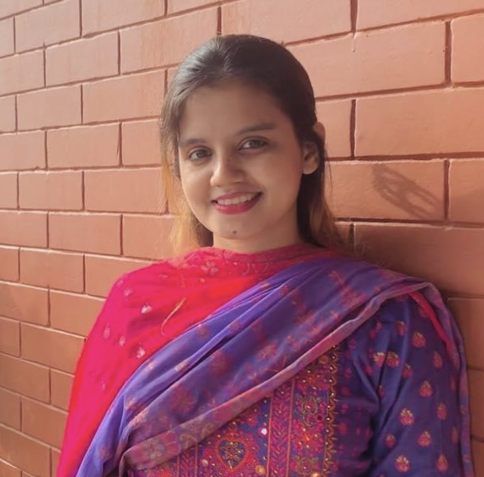

**Vedvedi Muslim para,Rangamati,Chattagram,Bangladesh**.

Contact No : 01768269291

Email: **[momotazmoon101@gmail.com](mailto:momotazmoon101@gmail.com)**

Github:**<https://github.com/Moonjahan>**

LinkedIn: <https://www.linkedin.com/in/moon-jahan-b2054a2a9?utm_source=share&utm_campaign=share_via&utm_content=profile&utm_medium=ios_app>

**PROFILE**

My academic knowledge and professional practices have led me to take challenging projects and enabled me to ensure diversified skills are in place while completing those projects within a given time frame. I am hardworking, dedicated, self-motivated, able to work individually and as a team.

**CARRIER OBJECTIVE**

Achieving a dynamic and challenging job in an organization where I can use my technical and interpersonal skills, creativity and all my learning experience in order to develop my career as well as to contribute in the welfare of the organization.

**JOB EXPERIENCES:**

| **Junior Assistant**  1st April 201**9**- 1st January 20**20** | P**ro** BetterBangladesh  **Rangamati,** **Chattagram,** Bangladesh. |
| --- | --- |

*Achievement:*

* Having knowledge ofmotivation**al** concept**s.**
* Capable to fix up production and shipment plan**.**
* Good Knowledge in differen**t** people’s perspectiv**e.** .

**COMPUTER SKILLS**

| Microsoft Office: Word | Intermediate Level |
| --- | --- |
| Operating System: Windows 7,8 & 10 | Intermediate Level |
| Internet Browsing & Email  Algorithmic Problem Solving & Competitive  Programming  C/C++ **language** | Semi-Expert Level  Intermediate Level  Intermediate Level |

**SKILLS**

* I am punctual, hardworking, honest and gentle.
* Excellent Attention to detail, organizational ability and accuracy.
* Basic Problem Solving skills with the ability to apply proven solutions
* I have enough patience and kindness.
* I can adapt myself with any situation and with any people
* I always try to help other people specially, who are helpless
* I Strongly believe in human right and peace.

**LANGUAGE PROFICIENCY**

| **Language** | **Reading** | **Writing** | **Listening** | **Speaking** |
| --- | --- | --- | --- | --- |
| Bengali | Native | Native | Native | Native |
| English | Excellent | Excellent | Excellent | Excellent |
|  |  |  |  |  |

**ACADEMIC QUALIFICATION**

**Bachelor of computer science and Engineering**

Institute name : Rangamati Science and Technology University

Board : Chattagram

Major : Computer Science and Engineering

**HIGHER SECONDARY SCHOOL CERTIFICATE (HSC)**

Institute name : Lakers Public School and College

Board : Chattagram

Group : Science

Year of completion : 2018

**SECONDARY SCHOOL CERTIFICATE (SSC)**

Institute name : Lakers Public School and College

Board : Chattagram

Group : Science

Year of completion : 2016

**PERSONAL INFORMATION**

Father's Name : Md. Abdul Matin

Mother's Name : Rina Akter

Present Address : Vedvedi Muslim Para ,Rangamati.

Permanent Address : Village: Muslimpara, Vedvedi, Ward No: 06,

Post Office: Rangamati-4500, Upazilla: Rangamati Sadar,

District: Rangamati.

Date of Birth : 14-11-2000

Nationality Bangladeshi by Birth

Religion : Islam

Gender : Male

Blood Group : A+

**REFERENCES**

| **Engr.Prof. Rana Jyoti Chakma**  DTM (USA), MIEEE (USA), MIPNZ (NZ)  Chairman, Pro Better Life (PBL) Bangladesh & CEO, PBL Swasti.  Ex-Chairman, Dept. of Computer Science & Engg. (CSE)  Rangamati Science and Technology University  Mobile:+88 01752398029  Email: ranachakma@gmail.com | **Dhiman sarma**  01981 642400, dhiman.sarma@ieee.org  Chairman and Assistant Professor, Department of CSE, RMSTU |
| --- | --- |